**Compile VPP with DPDK**

1. Download VPP code

# git clone <https://gerrit.fd.io/r/vpp>

1. Install the dependent tools

# make install-dep

One issue will be reported as below:



Resolve this issue above is delete the parameter “-E” in the Makefile file as below:

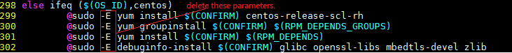

#install devtoolset

sudo yum install centos-release-scl-rh

sudo yum-config-manager --enable centos-sclo-rh-testing

#把centos-sclo-rh disable, 把centos-sclo-rh-testing enable

sudo vi /etc/yum.repos.d/CentOS-SCLo-scl-rh.repo

#列出devtoolset

yum list available | grep devtoolset

#安装devtoolset6

yum install devtoolset-6

#切换到gcc6

scl enable devtoolset-6 bash

#安装devtoolset7

yum install devtoolset-7

#切换到gcc7

scl enable devtoolset-7 bash

#退出gcc7

scl disable devtoolset-7 bash

1. Compile vpp code.

# make build (or make build-release)

1. Compile vpp code and build rpm packages.

# make pkg-rpm

Then, the rpm packages will be found in directory build-root/:

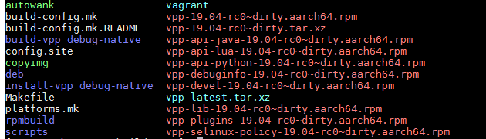

1. Install VPP rpm package

# cd build-root && rpm -ivh ./*.rpm

1. Config the VPP configuration (one example configuration file)



1. Start VPP service

# systemctl start vpp

1. Login in the VPP cli

# telnet localhost 5002

make install-ext-deps